**Mon_25963_Sylvie_PLSQL_Phase2_Report**

**Phase II – Business Process Modeling (MIS)**

**Course**: INSY 8311 – Database Development with PL/SQL  
 **Lecturer**: Eric Maniraguha  
 **Student Name**: Sylvie Iradukunda  
 **Student ID**: 25963  
 **Date**: March 25, 2025

### **Title:**

**Wildlife Poaching Threat Response Process (MIS Business Process Model)**

### **Scope:**

This process models the threat detection and ranger response workflow to poaching risks. It incorporates Management Information Systems (MIS) principles to enhance data-driven conservation and streamline field operations.

### **Objectives:**

* Automate threat detection and alerting using Oracle PL/SQL
* Minimize ranger response time through real-time alerts
* Provide consistent, data-backed reporting to conservation analysts and RDB

### **Key Entities & Roles:**

* **GPS Animal Tracker**: Sends animal location data
* **Incident Monitor System**: Receives data and calculates risk
* **Ranger Command Center**: Receives alert and dispatches patrols
* **Field Ranger**: Investigates and logs incident

### **Diagram:**

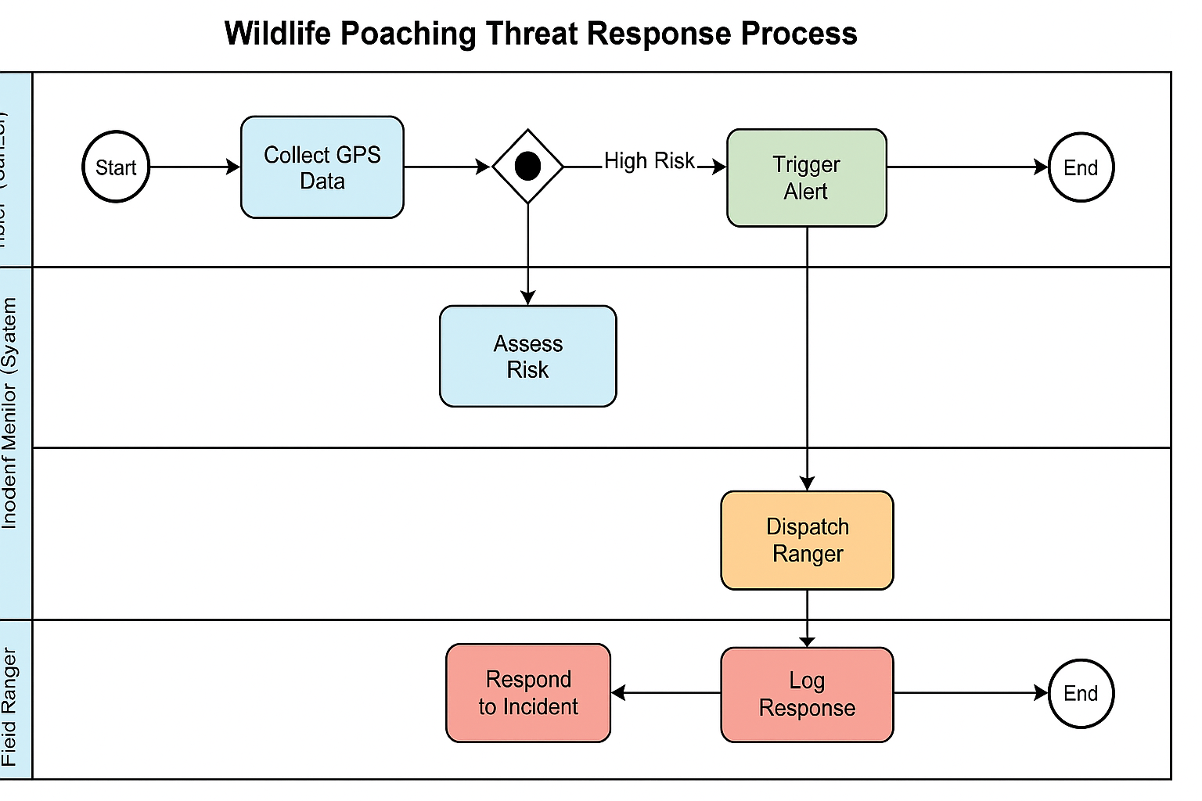

### **Description of the Diagram:**

The BPMN diagram uses swimlanes to visualize the following steps:

1. Animal trackers transmit location data.
2. The monitoring system processes data and runs a PL/SQL function to calculate poaching risk.
3. If a high threat is detected, a trigger initiates an alert to the command center.
4. The ranger unit is dispatched and responds to the threat.
5. Rangers log actions taken and submit a report.

### **MIS Relevance:**

This system directly supports MIS goals by:

* Supporting informed decision-making for ranger deployment
* Capturing accurate data for trend forecasting and planning
* Automating workflow between data collection and response

### **Importance for Efficiency:**

The process increases organizational responsiveness, maximizes conservation impact, and makes optimal use of limited ranger resources. It also ensures accountability and data integrity across all stages of response.

**End of Phase II**